Supplementary File 2

1. **Rate laws**

Supplementary Table 1: an overview of rate laws used by the metabolic enzymes of NAD pathway

|  |  |
| --- | --- |
| Enzyme | Rate law |
| NUDT12  SLC25A51  SLC25A17  mitoPARP  pexPARP | Competitive inhibition  Reversible Michaelis-Menten  Reversible Michaelis-Menten  Henri-Michaelis Menten Irreversible  Henri-Michaelis Menten Irreversible |

Michaelis- Menten (MM) Irreversible:

$$\frac{d\left[P\right]}{dt}=\frac{Vmax*\left[S\right]}{Km+[S]}$$

Michaelis- Menten (MM) Reversible

$$v=\frac{V_{max}^{s}×S-V_{max}^{p}×P}{1+\frac{S}{{Km}_{s}}+\frac{P}{{Km}_{p}}}$$

Competitive Inhibition:

$$\frac{Vmax+\left[S\right]}{Km+\left[S\right]+\frac{Km*inhibitior}{Ki}}$$

1. **Experimental Data used in the metabolic modelling**

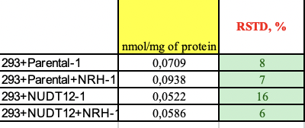

Data collected from NMN levels.

